**DAILY ONLINE ACTIVITIES SUMMARY**

|  |  |  |  |  |  |  |  |  |
| --- | --- | --- | --- | --- | --- | --- | --- | --- |
| **Date:** | **20/05/2020** | | | | | **Name:** | **ASHISH GRACION MENEZES** | |
| **Sem & Sec** | **4&A** | | | | | **USN:** | **4AL18CS012** | |
| **Online Test Summary** | | | | | | | | |
| **Subject** | | **MICROCONTROLLER AND EMBEDDED SYSTEM (1** | | | | | | |
| **Max. Marks** | | **30** | | **Score** | | | **19** | |
| **Certification Course Summary** | | | | | | | | |
| **Course** | **CLOUD FOUNDATION** | | | | | | | |
| **Certificate Provider** | | | **Great learning** | | **Duration** | | | **5 HOURS** |
| **Coding Challenges** | | | | | | | | |
| **Problem Statement1: To find shortest of palindrome** | | | | | | | | |
| **Status:Executed** | | | | | | | | |
| **Uploaded the report in Github** | | | | | **YES** | | | |
| **If yes Repository name** | | | | | **https://github.com/ash7745/lockdown-coding/blob/master/palindrome.java** | | | |
| **Uploaded the report in slack** | | | | | **YES** | | | |

Online Test Details:18CS43(OOC) test was scheduled from 9:30 am to 10:00 am and the syllabus for the exam was 1st module. There were 30 questions (mcq) and the time allotted for the test was 30 min

Certification Course Details

I have opted my Online Certification Course In great learning the course which opted is CLOUD FOUNDATION. This course contains assessments and practice assessments

**Cloud Foundation** is an integrated software stack that uses SDDC Manager an automated lifecycle management tool to bundle compute (vSphere), storage (VMware vSAN) and network virtualization (NSX) into a single platform that can deployed on premises as a private **cloud** or run as a service within a public

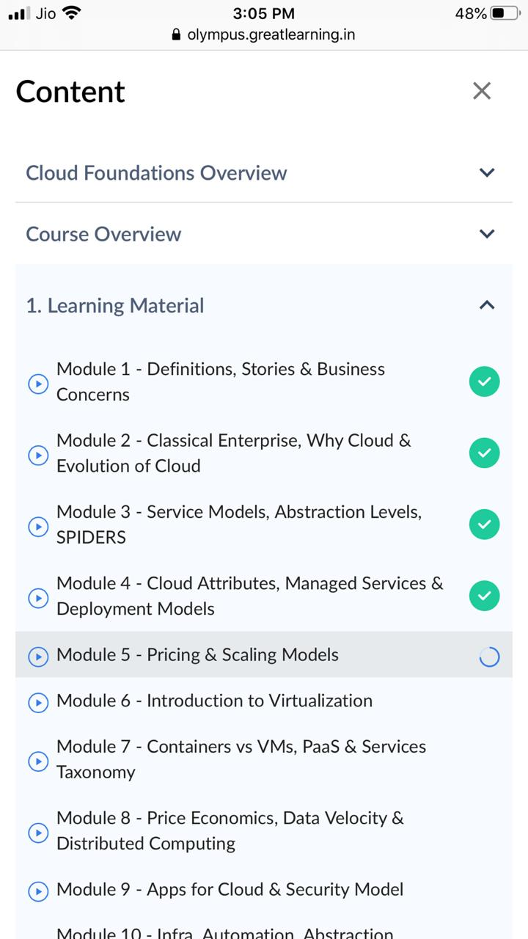

Coding Challenges Details: The program is to find shortest of palindrome

